DAY_28 Insurance Claims Analysis
Insurance Claims Analysis – Coding Challenge (Using Lists)
You are a Data Analyst working for an insurance company. You received raw claim data stored in lists.
Dataset (Lists)
policy_ids = [101, 102, 103, 104, 105, 106]
claim_amounts = [5000, 15000, 7000, 20000, 3000, 12000]
claim_status = ["Approved", "Rejected", "Approved", "Approved", "Rejected", "Approved"]
customer_age = [25, 45, 35, 50, 23, 40]
Tasks
Task 1: Total Approved Claim Amount
Calculate the total claim amount for all Approved claims.
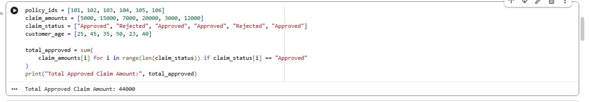
Task 2: Count Rejected Claims
Find how many claims are Rejected.
Task 3: High-Value Claims
Print all policy IDs where claim amount is greater than ₹10,000.
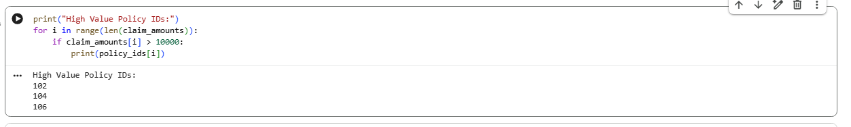

Task 4: Average Age of Approved Customers
Find the average age of customers whose claims are Approved.
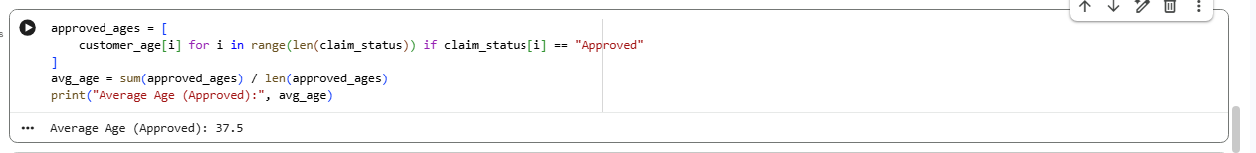
Task 5: Risk Category Tagging
Create a new list called risk_category:
Age < 30 → "Low Risk"
Age 30–45 → "Medium Risk"
